Biology course syllabus 2014-2015
Skyline High school

Instructor: Mr. Travis Schlagel and Mrs. Teddie Ryan
E-mail: schlagel_travis@svvsd.org or ryan_teddie@svvsd.org
Room: 234

Welcome to Biology!
Biology is the study of living things and how they interact with their environment. This year we will investigate living things and how they interact with their environment. We will also delve into the processes that allow life to continue and change. We will look at how animals and plants interact and provide food and necessary chemicals for each other, how organisms pass on genetic traits to their offspring and how organisms adapt to their ever-changing environments. In the end, you will have an understanding of the ways many different forms of life interact and depend on each other and how these interactions affect the world in which you live.
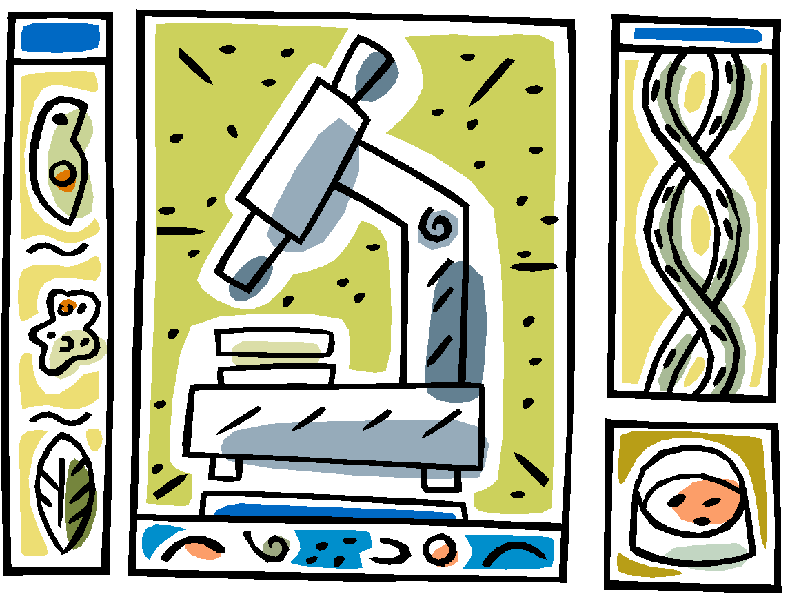
During the 1st semester we will be focusing on the following topics:
- Science Skills & Method
- Ecology
- Biochemistry
- Cell Structure & Function

During the 2nd semester we will be focusing on the following topics:
- Photosynthesis and Cellular Respiration
- DNA & Genetics
- Natural Selection
- Body Systems
Classroom Procedures
The following procedures are in place to ensure all students have an equal opportunity to learn:
- Please be in your seat and ready to learn (all materials out and ready) when the bell rings.
- Be Safe: Follow all lab and classroom safety and learning procedures.
- Be Respectful: To each other, to your instructors, and of the materials in the room.
- Be Responsible: For your words and actions. Be here, be ready and be a learner.
Attendance & Tardies
- Excused Absences:
If you are absent, it is your responsibility to come to me either before class or after class to pick up what you missed. I will also have an organizer of the most recent work we have done in class that you should check as well. You may also need to sign up for lunch study hall to make up an assessment, make up a lab or get help on an assignment. You are allowed one (1) day for each day that you were absent to make-up and turn in any missed assignments, labs or assessments. Materials and assignments will be available for one week from the day they were first assigned. You may also access the biology website at www.skylinebiology.weebly.com to see what you missed and access some handouts.

- Tardies:
Tardies disrupt the class and disrespectful to the instructor and your fellow classmates. The consequences for being tardy are as follows:
- 1st Tardy: a verbal warning from me
- 2nd Tardy: you will need to stay after class and write a 1 page paper on why being on time is essential
- 3rd Tardy: Science lunch detention & call home to parent / guardian
- Any additional Tardies: Behavior referral to administration

- Unexcused Absences:
Being present in class is essential to your success. Making the choice to miss class jeopardizes your successful completion of this class. I will contact your parents on your 1st and 2nd unexcused absences. On your 3rd unexcused absence I will fill out an attendance behavior referral, which is given to your administrator.
Being present is essential to your success in this class. It is understandable that you may become sick and we do not want you coming to school and spreading germs if you are. However, it is difficult to catch up when you have missed discussions, demonstrations, labs and activities that cannot be done outside of class, therefore, please make every effort to be in class at all other times. All assignments, labs & assessments will be available for one week. After this time, you will longer be able to make-up those assignments and will receive a score of “missing” in the grade-book.
Make-up Assignments & Late Assignments
1. Make-up Work: If you are absent you get one day for each day that you were gone to make up missing assignments. You may need to sign-up for a lunch session to make-up labs, assessments or get help on an assignment.
2. Late Work: Assignments are expected to be turned in on time. The information you learn from your assignments is essential for your success on future assignments and assessments; therefore, turning assignments in late can jeopardize your success in this class. If you attend a lunchtime session you may turn an assignment in late with no penalty. Late assignments turned in without attending a lunchtime session will not receive a grade higher than a 70%.
Grading
Your overall grade is broken down into the following categories and weights:
- 40% Tests, quizzes
- 20% Projects & Lab Reports
- 20% Daily work: homework, classroom activities, warm-ups, class discussion, binder, check-outs, timesheets
- 20% Semester Final Exam
Keep in mind that how you do on your assessments depends largely on how much effort you put into your daily work. So, even though the daily work is only worth 20% in the grade-book, your efforts in this area will also be shown in your assessment scores which are worth considerably more.
Materials
The following materials are required for this class:
A 1 ½ inch binder, loose-leaf paper, pens and pencils, tabbed dividers for your binder, composition notebook

The following materials are helpful, but not required:
Calculator, colored pencils, hand-held pencil sharpener

I expect you will have your required materials with you every day. I do not have pencils or pens for student use. Your binder and notebook need to be organized and with you on a daily basis. I will be doing regular binder and notebook checks as part of your daily grade. All notes, graded assignments, assessments, warm-ups, timesheets, vocabulary and practice need to be in your binder and notebook and neatly organized for the notebook check.

Electronics
Electronics of any kind are not allowed in science class. Please leave these items, including headphones, in your locker or your backpack. If I see them out for any reason, I will confiscate them and bring them to the office where you will be responsible for picking them up from an administrator after school.

Food & Drinks:
Food and drinks are not allowed in science class. Water is allowed in a clear bottle.

Extra Help
Please talk with me if you feel that you are falling behind or if you are need additional help with understanding a topic. The sooner you let me know you would like some additional help, the sooner we can get you caught up.

Note to Parents:

We are all on the same team. Here are some steps you can take to ensure your child is successful!

- Check your child’s grades on Infinite Campus! There is a link on the school web page that will allow you to see your child’s grades and attendance on a daily basis. I usually enter in grades no later than 2 days after the assignment is due and I try my best to stay up to date. There is even an app you can download to your phone!
- There is a Website that will contain all of the learning goals and unit plans for every unit skylinebiology.weebley.com. This is a work in progress and my hopes are to upload most of the assignments and notes to the web page throughout the year.
- Check that your child has an organized notebook. Your student should be able to show you what he/she did in class each day. There will be notebook checks every unit for a grade and it is an easy way for your child to improve their grade.
- Monitor your child’s attendance! If a student is absent, it is their responsibility to see me for any work they may have missed. Biology is a laboratory-based science, meaning that we will be doing labs that cannot be completed outside of the classroom. If students miss class, it is a good idea for them to spend some extra time with me to get caught up either before or after school.
- Also please note the portion on “Electronics”. Cellular devices, music and smartphones are a huge distraction for most students. They should not be checking facebook or listening to music during instruction. It is a science department policy that I send students to the office if I see them. Your support on this is much appreciated.
- I respond very quickly to e-mail. So if you should ever have any concerns, issues or questions, don’t hesitate to contact me! schlagel_travis@svvsd.org

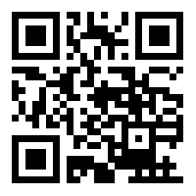

Scan this!!

Please read over my expectations and sign below.
Please keep the top half to refer to contact information and expectations.

I have read, understand and agree to abide by the procedures and policies of Mr. Schlagel’s biology class.

Student___________________________________________ Parent / Guardian ___________________________________

Parent/ Guardian Phone _______________________________

Parent/ Guardian Email________________________________

